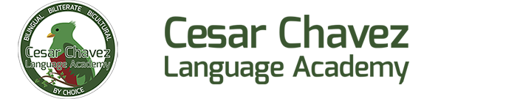

Date
Dear (company name or person to whom you are writing),
My child’s school, Cesar Chavez Language Academy, is raising money to add more enrichment and STEAM programs for our students.
This school year, Cesar Chavez Language Academy Foundation realizes the importance of promoting healthy behaviors in our youth. Therefore, instead of selling unwanted or unhealthy merchandise they are choosing to raise money through a Cash Drive.
To help the school reach their monetary goal (Your Child’s name) is participating in the Cash Drive. This fundraiser is 100% donation-based and we want to achieve the donation goal. My child has raised a total of (Student Total)
To help the school reach their goal I am inquiring to see if (Employer/Company name) will match the total donations that we’ve collected as a family and/or contributed ourselves. The donation would be a tax deduction and (Employer/Company Name) would be supporting our community.
Cesar Chavez Language Academy Foundation with tax ID 47-5054324 will send you an official receipt for any donation amount or more. If you make any donation online, you will receive an email receipt with the tax ID # as well.
Thank you for your consideration in our efforts as we work to better our school and community!
Best Regards
(Your name)

